SerialEvent

This example demonstrates use of the SerialEvent() function. This function is called inside the loop(). If there is serial data in the buffer each character found is added to a string until a newline is found. In this case the string made by the characters received so far is printed and set back to null.

Hardware Required

* Arduino or Genuino Board

Circuit

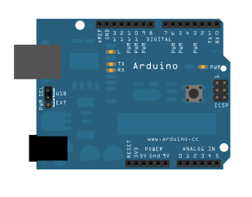

None, but the board has to be connected to the computer; the Arduino Software (IDE) serial monitor may be used to communicate the single or multiple characters and receive the string back.

Code

String inputString = "";         *// a String to hold incoming data*  
bool stringComplete = false;  *// whether the string is complete*  
  
void **setup**() {  
  *// initialize serial:*  
  Serial.begin(9600);  
  *// reserve 200 bytes for the inputString:*  
  inputString.reserve(200);  
}  
  
void **loop**() {  
  *// print the string when a newline arrives:*  
  if (stringComplete) {  
    Serial.println(inputString);  
    *// clear the string:*  
    inputString = "";  
    stringComplete = false;  
  }  
}  
  
*/*  
  SerialEvent occurs whenever a new data comes in the hardware serial RX. This routine is run between each time loop() runs, so using delay inside loop can delay response. Multiple bytes of data may be available.  
*/*  
void serialEvent() {  
  while (Serial.available()) {  
    *// get the new byte:*  
    char inChar = (char)Serial.read();  
    *// add it to the inputString:*  
    inputString += inChar;  
    *// if the incoming character is a newline, set a flag so the main loop can*  
    *// do something about it:*  
    if (inChar == '**\n**') {  
      stringComplete = true;  
    }  
  }  
}